UNITED STATES

SECURITIES AND EXCHANGE COMMISSION

Washington, D.C. 20549

SCHEDULE 14A

Proxy Statement Pursuant to Section 14(a) of the

Securities Exchange Act of 1934

Filed by the Registrant ☒

Filed by a Party other than the Registrant ☐

Check the appropriate box:

- Preliminary Proxy Statement

- Confidential, for Use of the Commission Only (as permitted by Rule 14a-6(e) (2))

- Definitive Proxy Statement

- Definitive Additional Materials

- Soliciting Material Pursuant to Section 240.14a-12

Payoneer Global Inc.

(Name of Registrant as Specified In Its Charter)

(Name of Person(s) Filing Proxy Statement if other than the Registrant)

Payment of Filing Fee (Check the appropriate box):

- No fee required.

- Fee paid previously with preliminary materials

- Fee computed on table in exhibit required by Item 25(b) per Exchange Act Rules 14a-6(i)(1) and 0-11

This Schedule 14A relates solely to preliminary communications made prior to furnishing security holders of Payoneer Global Inc. (the “Company”) with a definitive proxy statement related to a proposed transaction in which Panda Acquisition Sub Inc., a Delaware corporation and a wholly owned subsidiary of Neon Maple Parent Inc., a corporation incorporated pursuant to the laws of Canada (“Nuvei”), will merge with and into the Company, with the Company surviving the merger as a wholly owned subsidiary of Nuvei.

***

This Schedule 14A filing consists of materials for employees that were published on the Company’s intranet on June 23, 2026 relating to the transaction:
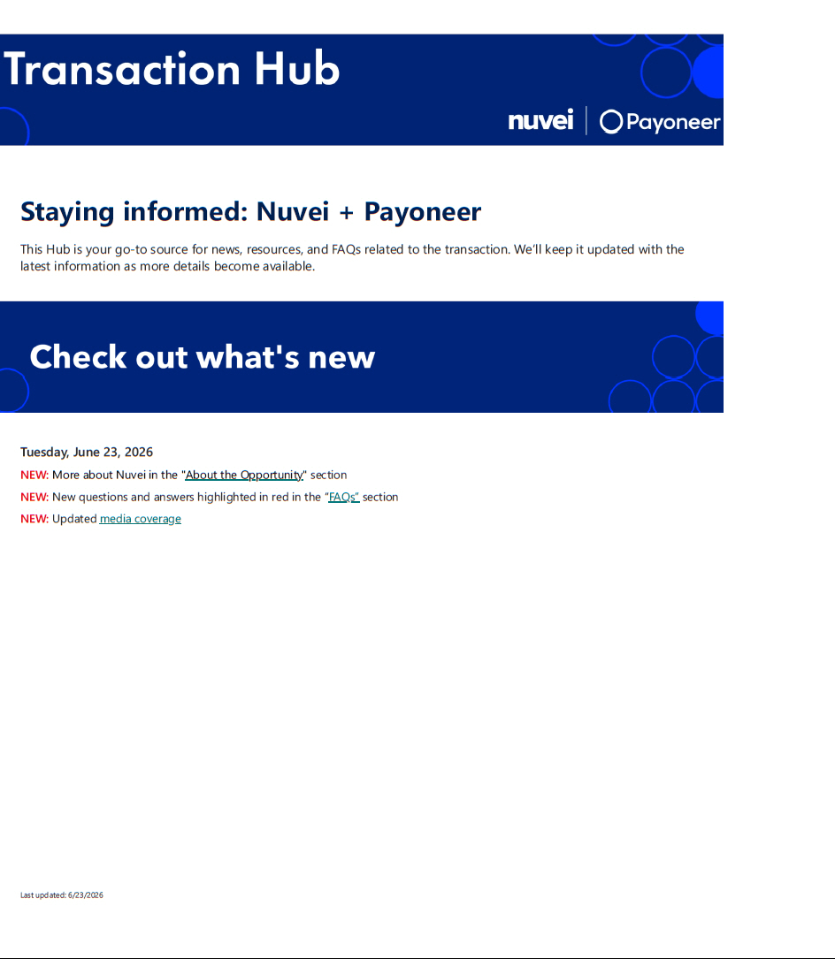

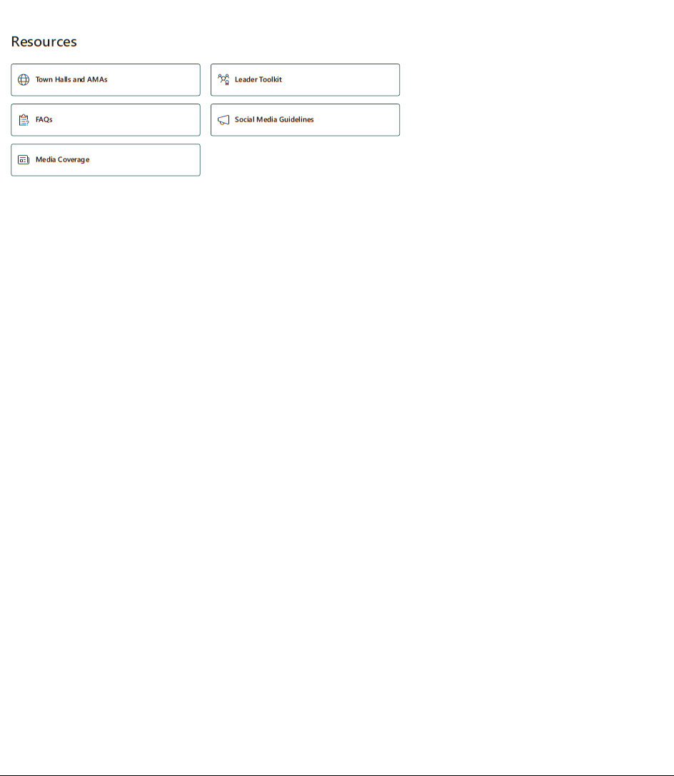

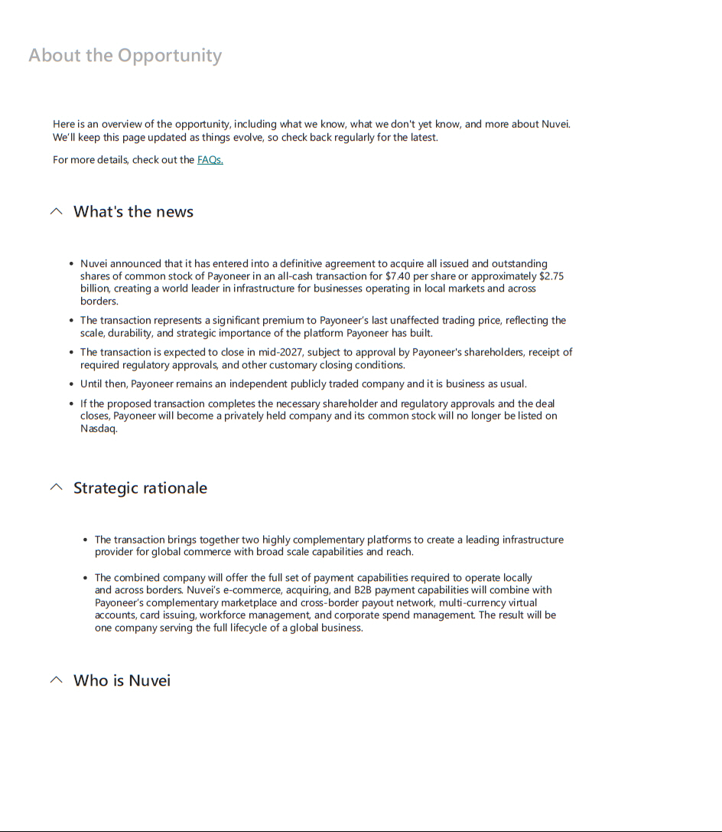

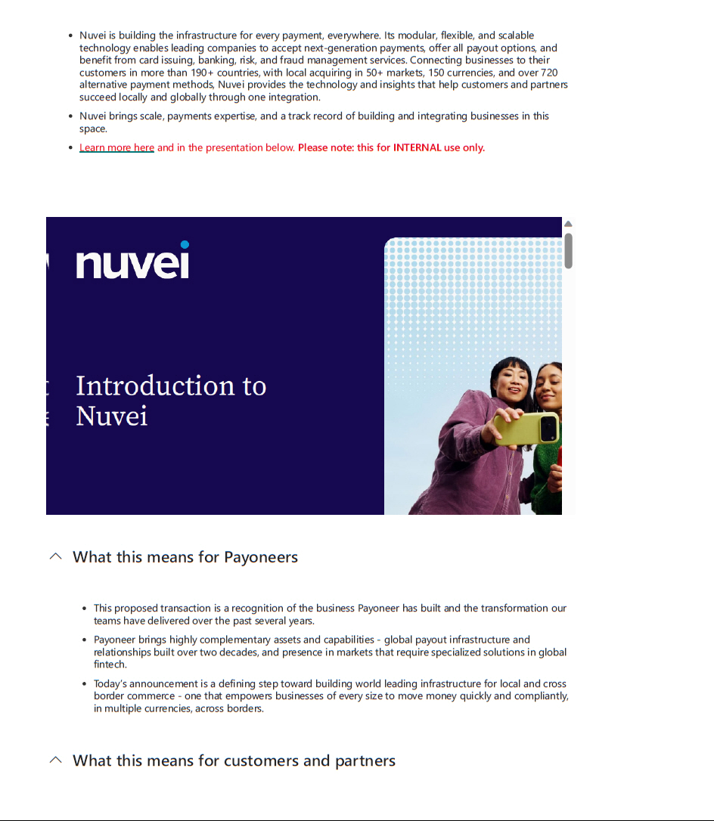

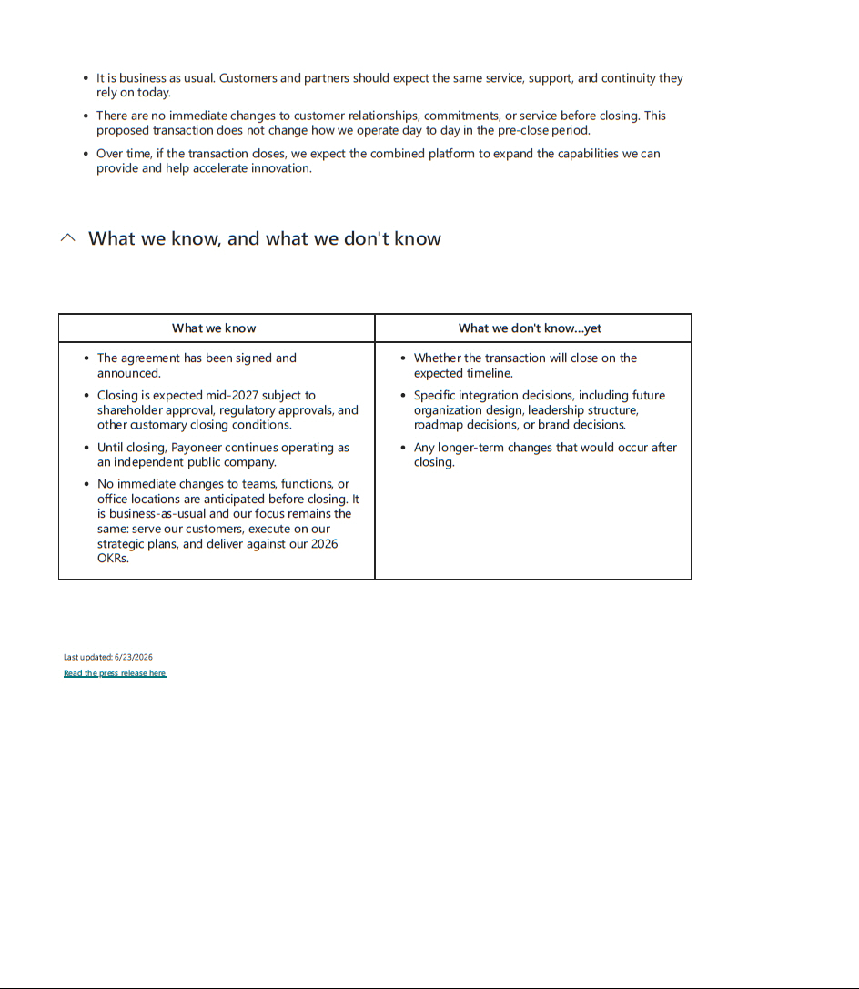



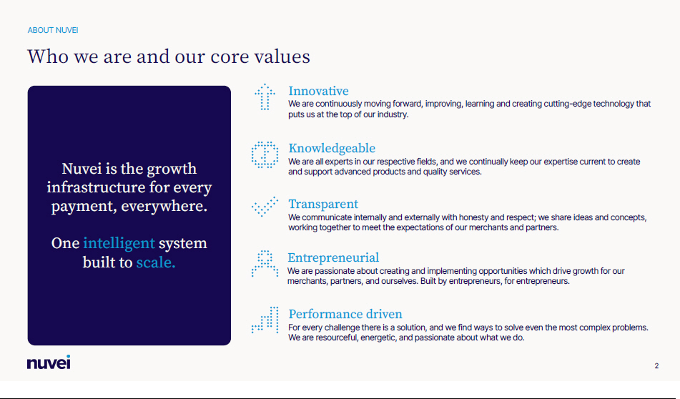

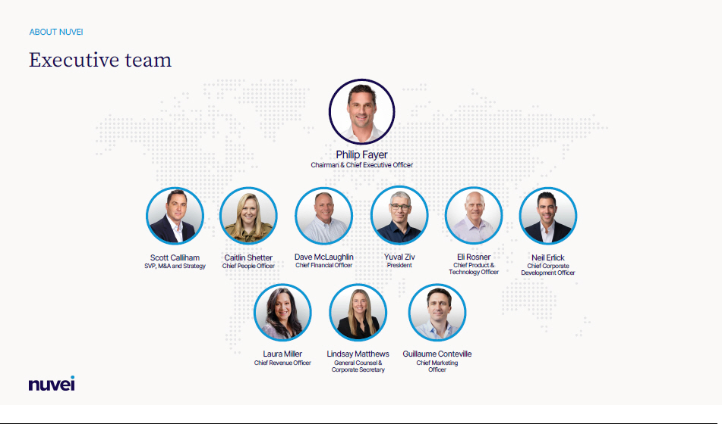

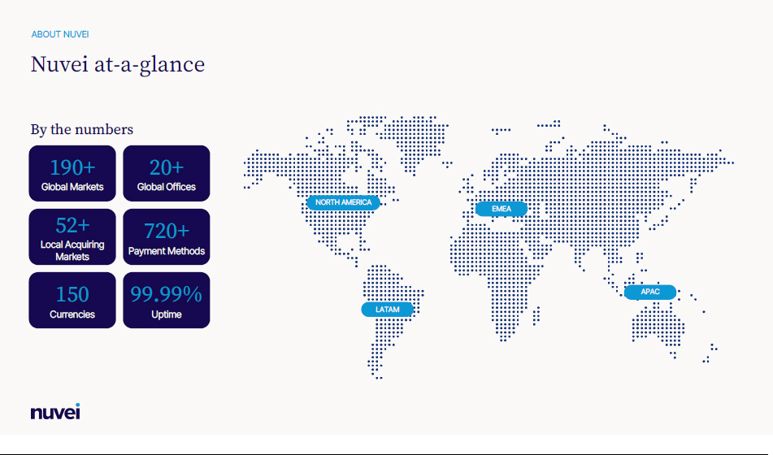

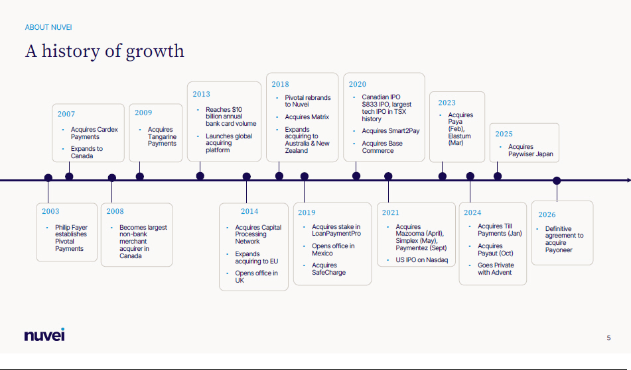

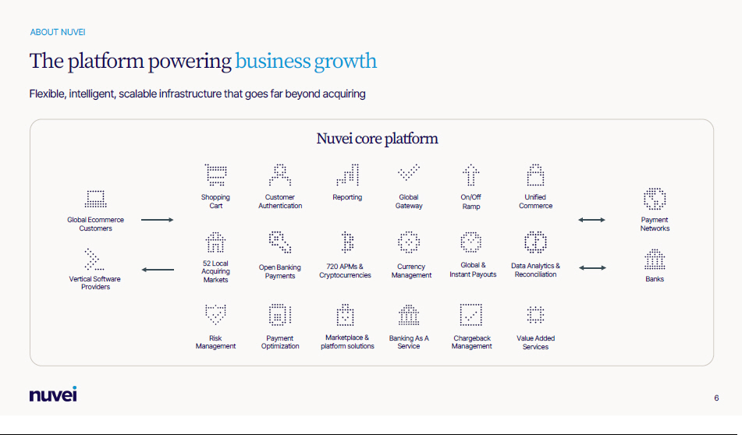

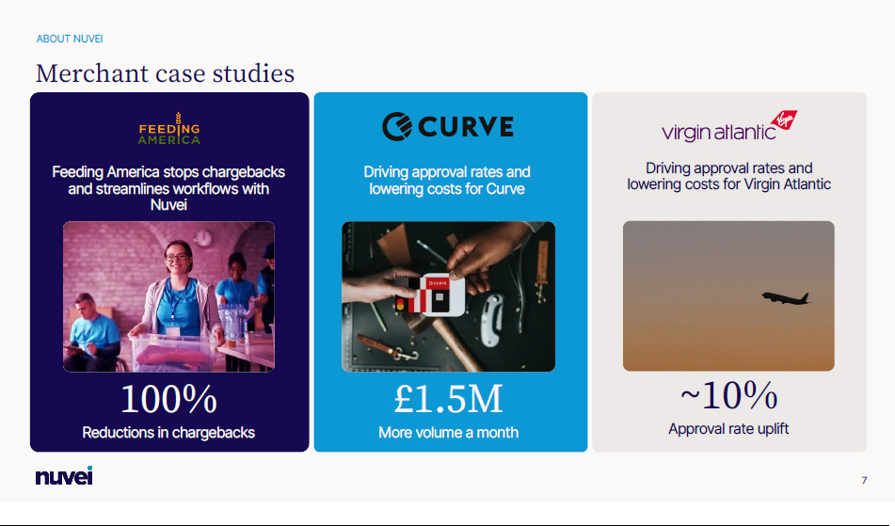

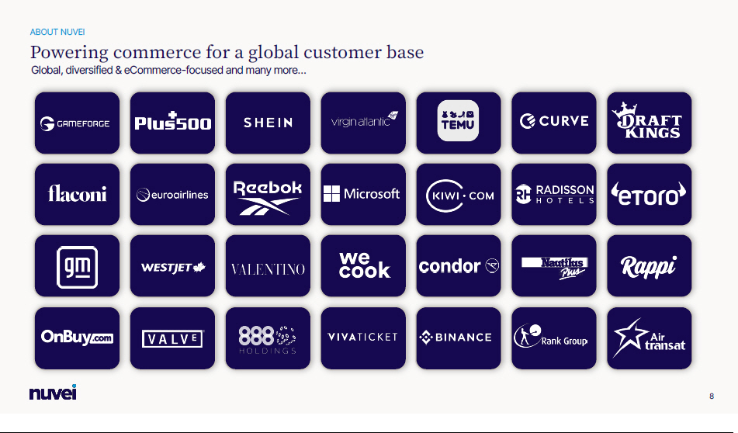



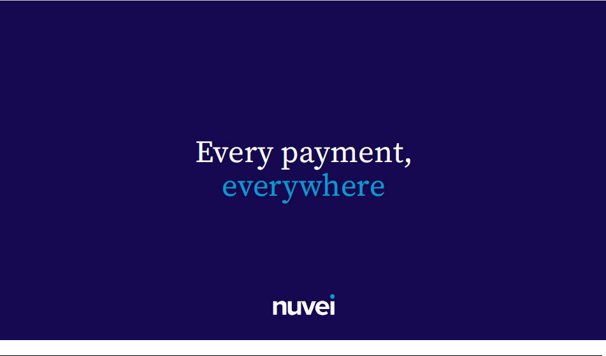

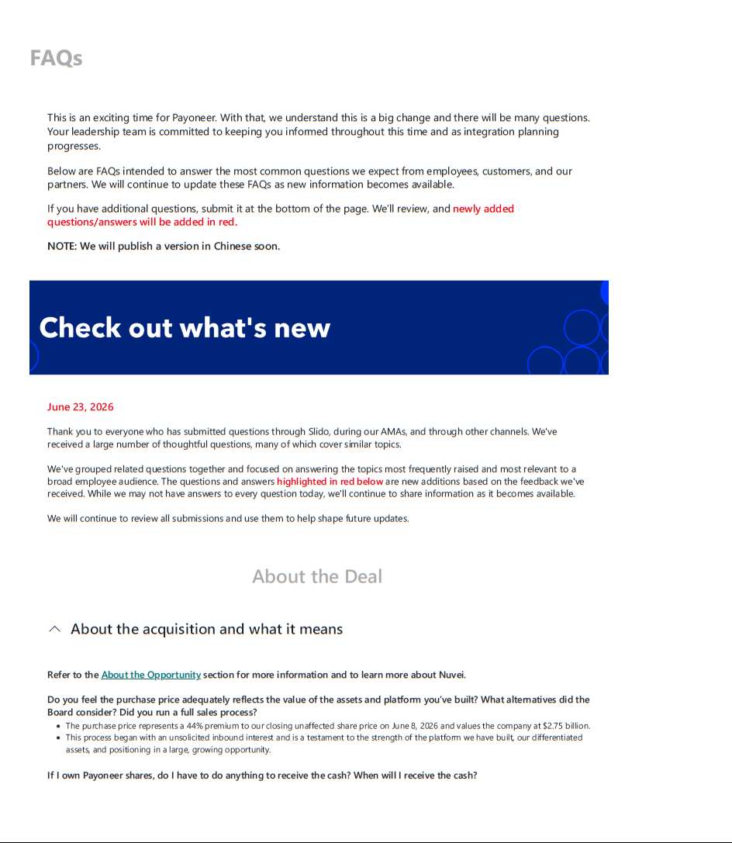

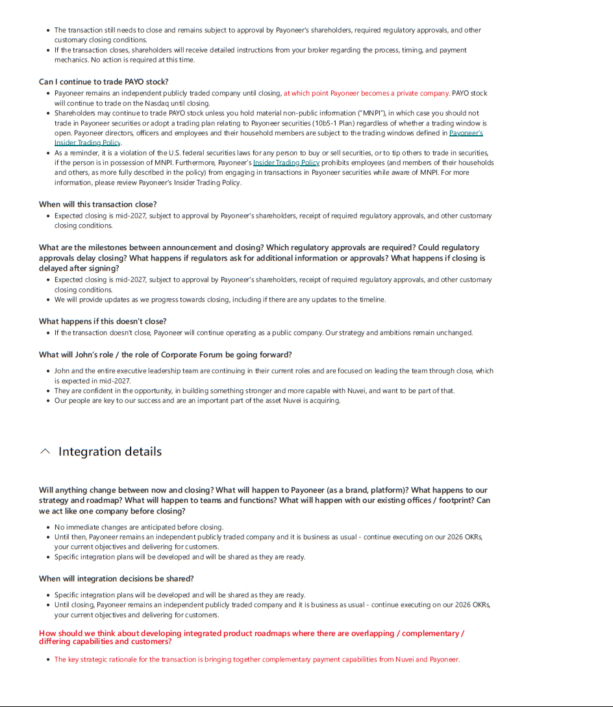

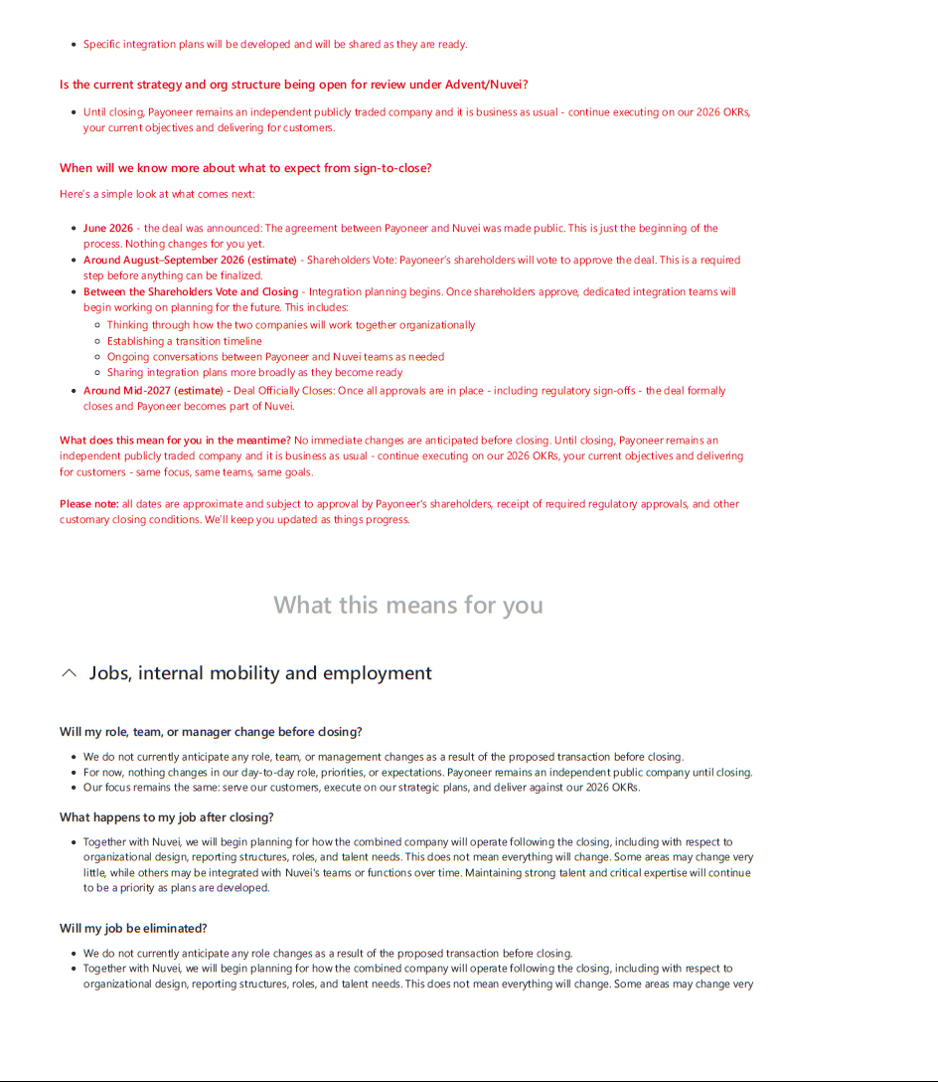

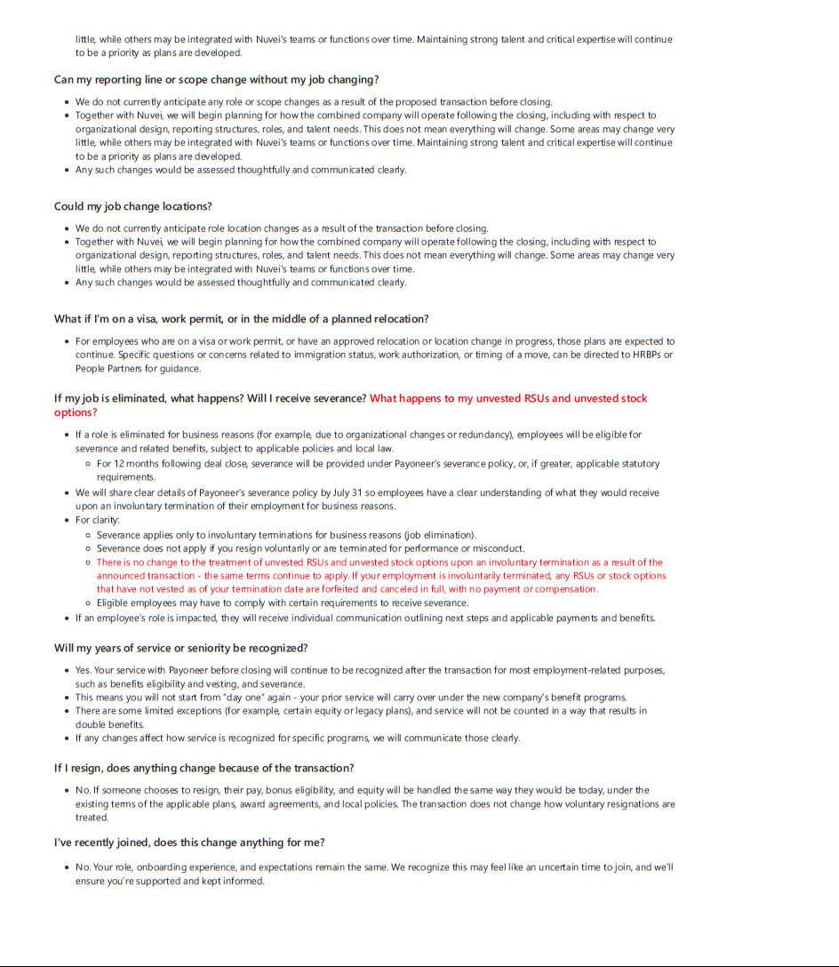

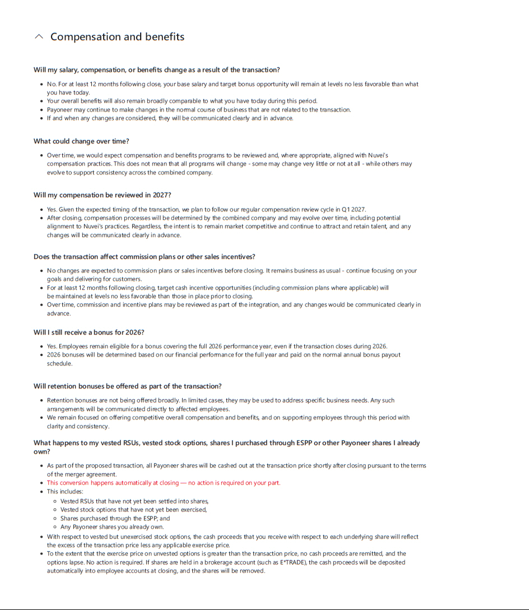

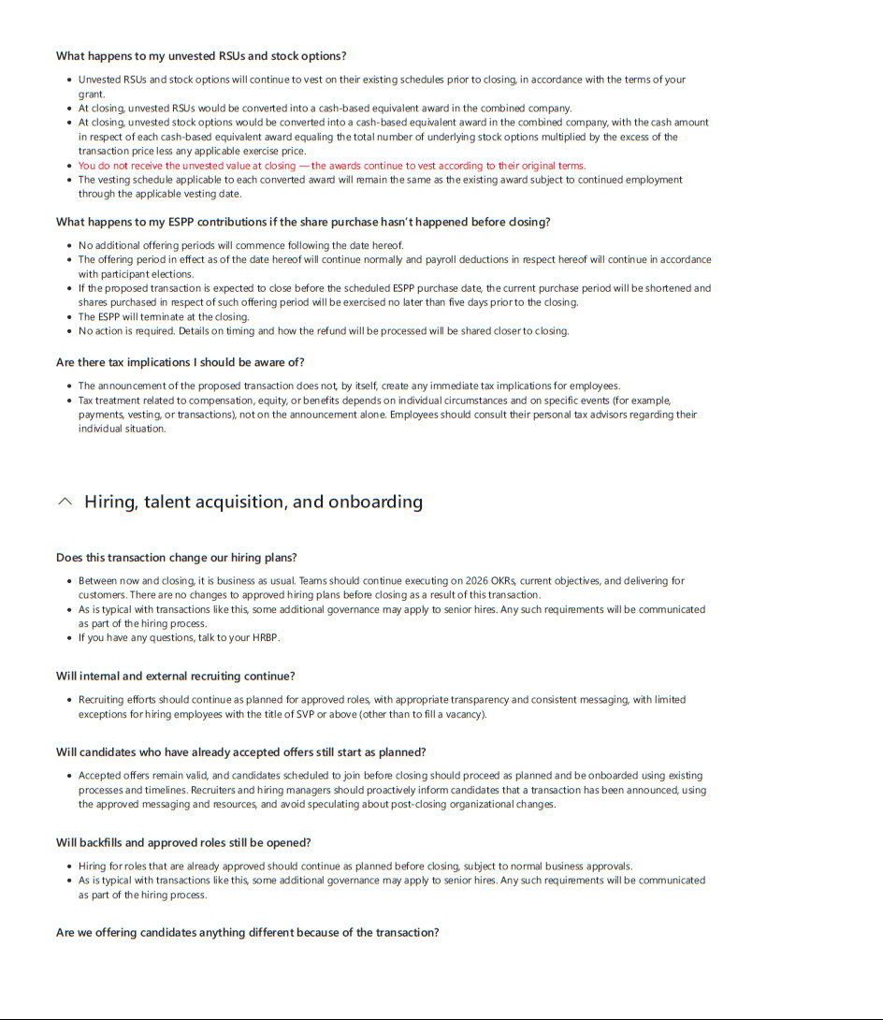

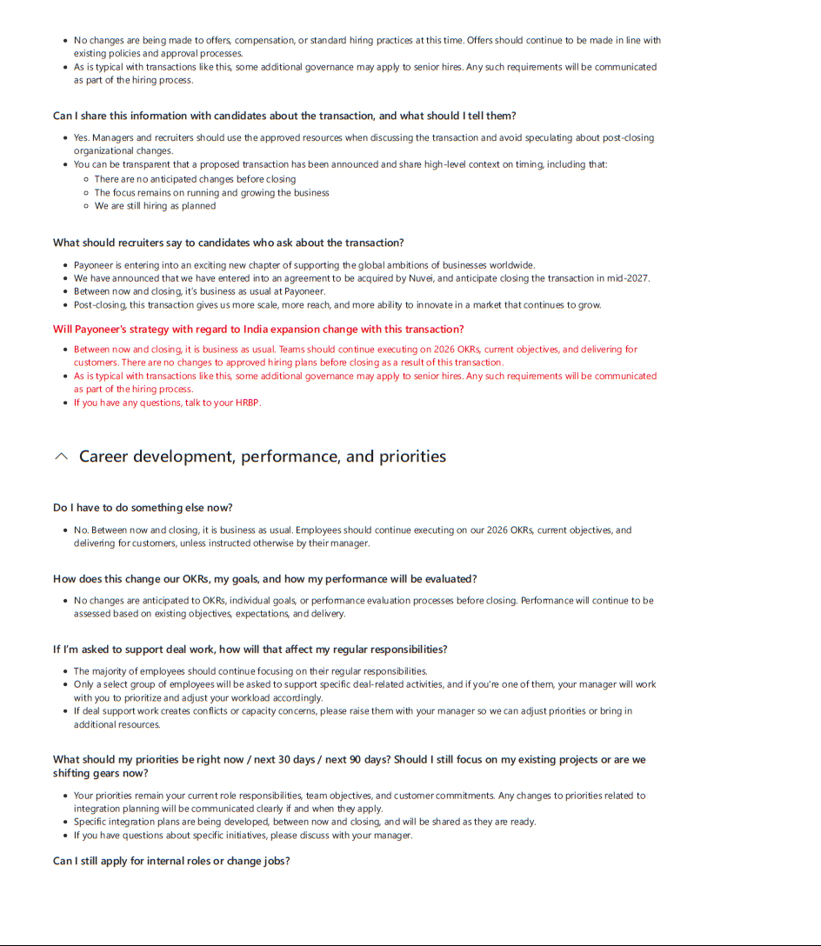

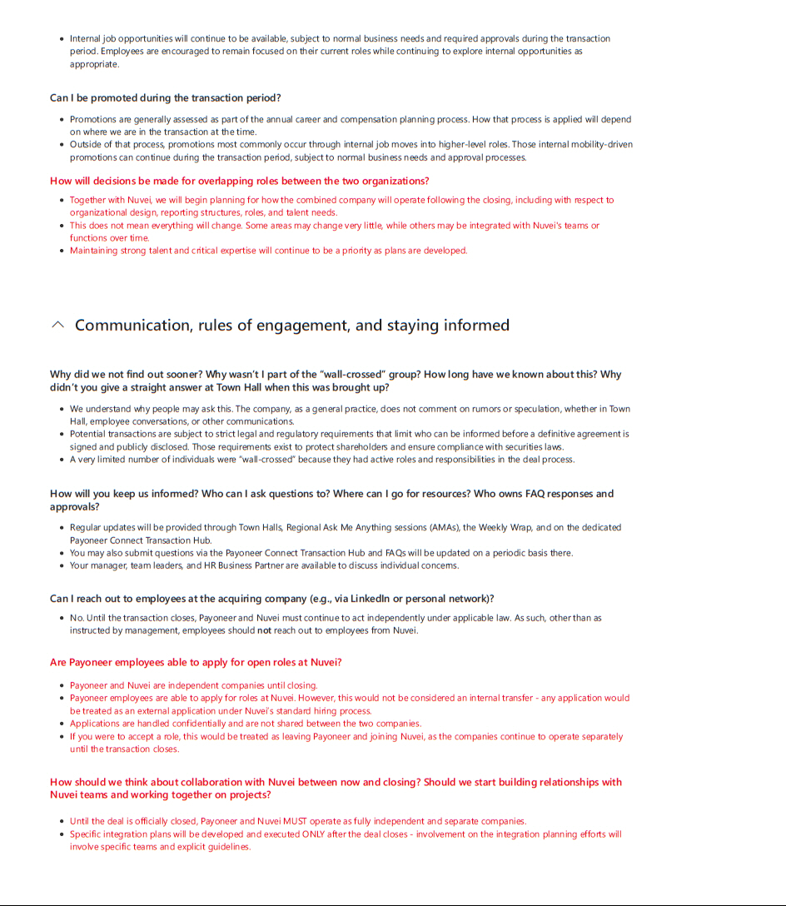

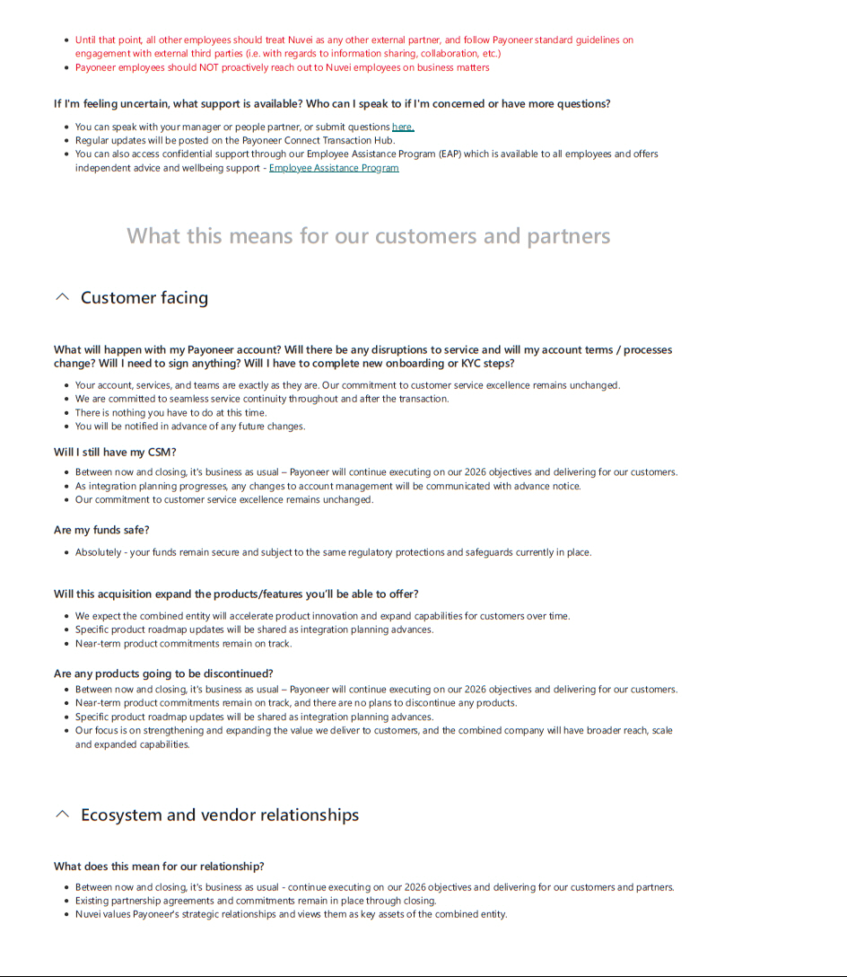

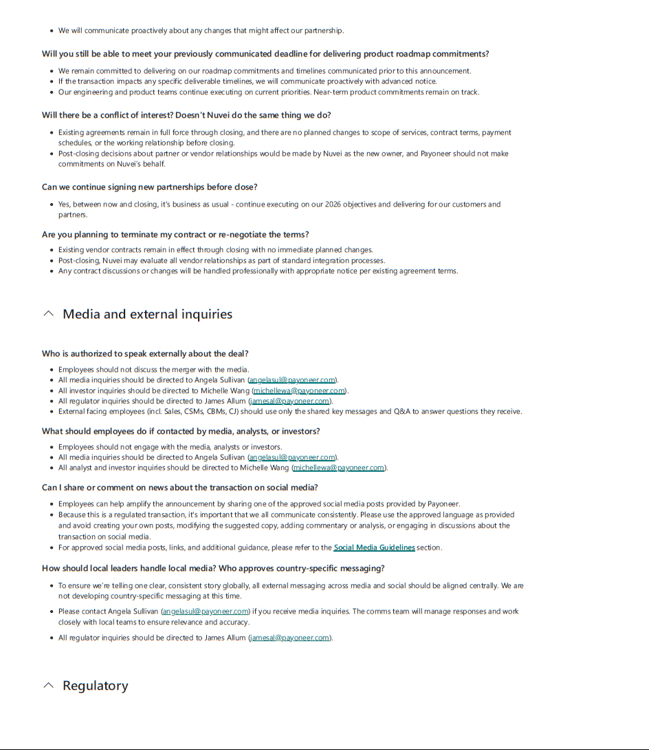

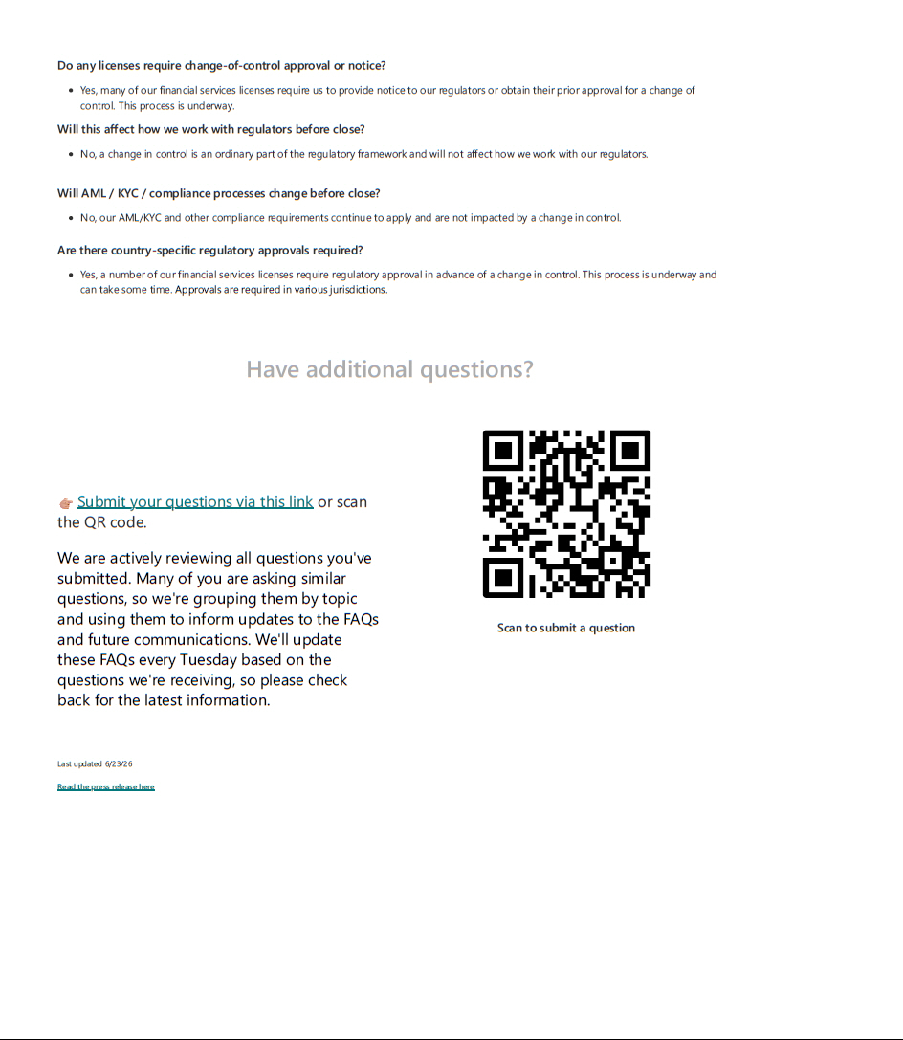

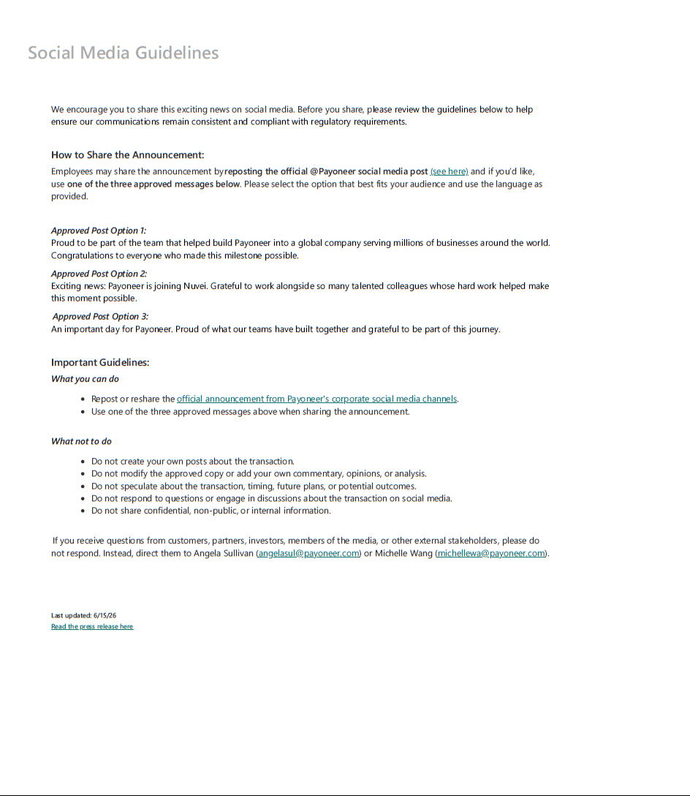

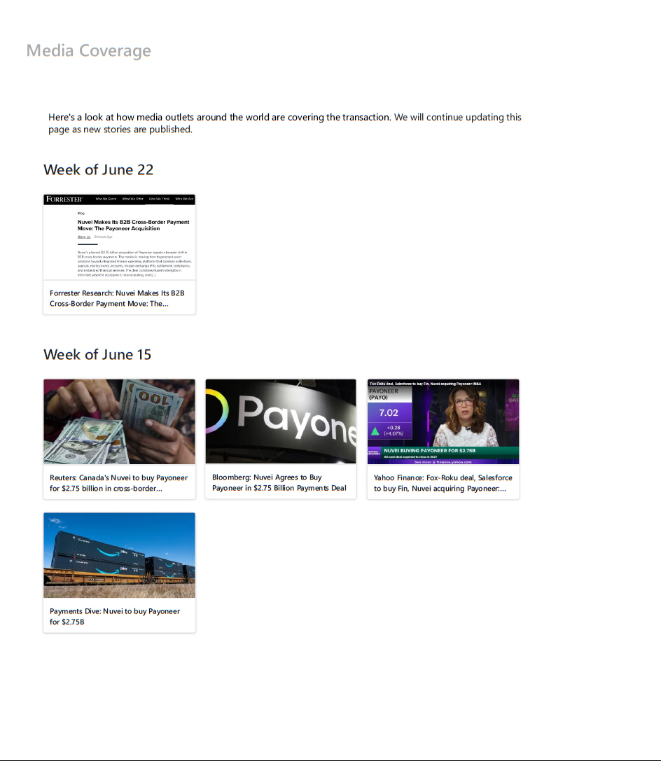



Forward-Looking Statements

Cautionary Statement Regarding Forward-Looking Statements

This communication contains forward-looking statements within the meaning of the Private Securities Litigation Reform Act of 1995 (the “Act”). Except for historical information contained in this communication, the matters discussed herein contain forward-looking statements that involve risks and uncertainties. Such statements are provided under the “safe harbor” protection of the Act. In some cases, you can identify forward-looking statements because they contain words such as “may,” “will,” “shall,” “should,” “expects,” “plans,” “positioning,” “anticipates,” “could,” “intends,” “target,” “projects,” “contemplates,” “believes,” “estimates,” “predicts,” “potential” or “continue” or the negative of these words or other similar terms or expressions that concern our expectations, strategy, plans or intentions. Forward-looking statements include, but are not limited to, statements about transition and the impact of recent changes to our executive management team; statements regarding the expectations of demand for our products and cash flow generation; statements about improvements to and expansion of our products and platform, and launching new products; statements about future operating results, including revenue, volume, growth opportunities, variability of expenses, ability to realize efficiencies, future spending and incremental investments, business trends, our ability to deliver profits, and growth and value for shareholders; and assumptions regarding foreign exchange rates.

Forward-looking statements by their nature address matters that are, to different degrees, uncertain, such as statements regarding the transactions (the “Transaction”) contemplated by the Agreement and Plan of Merger, dated as of June 12, 2026, by and among Payoneer Global Inc. (the “Company”), Neon Maple Parent Inc. (“Nuvei”) and Panda Acquisition Sub Inc. (the “Merger Agreement”), including the expected time period to consummate the Transaction. All such forward-looking statements are based upon current plans, estimates, expectations and ambitions that are subject to risks, uncertainties and assumptions, many of which are beyond the control of the Company, that could cause actual results to differ materially from those expressed in such forward-looking statements. Key factors that could cause actual results to differ materially include, but are not limited to, the expected timing and likelihood of completion of the Transaction, including the timing, receipt and terms and conditions of any required governmental and regulatory approvals of the Transaction; the occurrence of any event, change or other circumstances that could give rise to the termination of the Merger Agreement; the possibility that the Company’s stockholders may not approve the Transaction; the risk that the parties may not be able to satisfy the conditions to the Transaction in a timely manner or at all; risks related to disruption of management time from ongoing business operations due to the Transaction; the risk that any announcements relating to the Transaction could have adverse effects on the market price of the Company’s common stock; the risk that the Transaction and its announcement could have an adverse effect on the parties’ business relationships and business generally, including the ability of the Company to retain customers and retain and hire key personnel and maintain relationships with their suppliers and customers, and on their operating results and businesses generally; the risk of unforeseen or unknown liabilities; customer, stockholder, partner, regulatory and other stakeholder approvals and support; the risk of unexpected future capital expenditures; the risk of potential litigation relating to the Transaction that could be instituted against the Company or its directors and/or officers; the risk associated with third party contracts containing material consent, anti-assignment, transfer or other provisions that may be related to the Transaction which are not waived or otherwise satisfactorily resolved; the risk of various events that could disrupt operations, including severe weather, such as droughts, floods, avalanches and earthquakes, cybersecurity attacks, wars, security threats and governmental response to them, and technological changes; the risks of labor disputes, changes in labor costs and labor difficulties; and the risks resulting from other effects of industry, market, economic, legal or legislative, political or regulatory conditions outside of the Company’s control. All such factors are difficult to predict and are beyond our control, including those detailed in the Company’s annual report on Form 10-K for the fiscal year ended December 31, 2025 (and which is available at https://www.sec.gov/Archives/edgar/data/1845815/000110465926020487/payo-20251231x10k.htm), quarterly reports on Form 10-Q and other documents subsequently filed by

the Company with the Securities Exchange Commission (“SEC”) and that are available at

https://www.sec.gov/edgar/search/#/ciks=0001845815&entityName=Payoneer%2520Global%2520Inc.%2520(PAYO)%2520(CIK%25200001845815). The Company’s forward-looking statements are based on assumptions that the Company believes to be reasonable but that may not prove to be accurate. Other unpredictable or factors not discussed in this communication could also have material adverse effects on forward-looking statements. The Company does not assume an obligation to update any forward-looking statements, except as required by applicable law. These forward-looking statements speak only as of the date hereof.

Additional Information and Where to Find It

In connection with the Transaction, the Company will file with the SEC a proxy statement on Schedule 14A. The definitive proxy statement will be sent to the stockholders of the Company seeking their approval of the Transaction and other related matters. INVESTORS AND SECURITY HOLDERS ARE URGED TO READ THE PROXY STATEMENT ON SCHEDULE 14A WHEN IT BECOMES AVAILABLE, AS WELL AS ANY OTHER RELEVANT DOCUMENTS FILED WITH THE SEC IN CONNECTION WITH THE TRANSACTION OR INCORPORATED BY REFERENCE INTO THE PROXY STATEMENT, BECAUSE THEY WILL CONTAIN IMPORTANT INFORMATION REGARDING THE COMPANY, THE TRANSACTION AND RELATED MATTERS. Investors and security holders may obtain free copies of these documents, including the proxy statement, and other documents filed with the SEC by the Company through the website maintained by the SEC at https://www.sec.gov/edgar/browse/?CIK=1845815&owner=exclude. Copies of documents filed with the SEC by the Company will be made available free of charge by accessing the Company’s website at https://investor.payoneer.com/financials/sec-filings.

Participants in the Solicitation

The Company, Nuvei and their respective directors and executive officers may be deemed to be participants in the solicitation of proxies from the stockholders of the Company in connection with the Transaction under the rules of the SEC. Information about the interests of the directors and executive officers of the Company and other persons who may be deemed to be participants in the solicitation of stockholders of the Company in connection with the Transaction and a description of their direct and indirect interests, by security holdings or otherwise, will be included in the proxy statement related to the Transaction, which will be filed with the SEC. Information about the directors and executive officers of the Company and their ownership of the Company common stock is also set forth in the Company’s definitive proxy statement in connection with its 2026 Annual Meeting of Stockholders, as filed with the SEC on April 27, 2026 (and which is available at https://www.sec.gov/ix? doc=/Archives/edgar/data/0001845815/000110465926049462/tm261500-1_def14a.htm) and in the Company’s Annual Report on Form 10-K for the fiscal year ended December 31, 2025 (and which is available at https://www.sec.gov/ix?doc=/Archives/edgar/data/0001845815/000110465926020487/payo-20251231x10k.htm). Information about the directors and executive officers of the Company, their ownership of the Company common stock, and the Company’s transactions with related persons is set forth in the sections entitled “Directors, Executive Officers and Corporate Governance,” “Security Ownership of Certain Beneficial Owners and Management and Related Stockholder Matters,” and “Certain Relationships and Related Transactions, and Director Independence” included in the Company’s annual report on Form 10-K for the fiscal year ended December 31, 2025, which was filed with the SEC on February 26, 2026 (and which is available at https://www.sec.gov/ix? doc=/Archives/edgar/data/0001845815/000110465926020487/payo-20251231x10k.htm), and in the sections entitled “Information Regarding the Board of Directors and Corporate Governance,” “Security Ownership of Certain Beneficial Owners and Management,” “Certain Relationships and Related Party Transactions,” and “Independence of the Board of Directors” included in the Company’s definitive proxy statement in connection with its 2026 Annual Meeting of Stockholders, as filed with the SEC on April 27, 2026 (and which is available at https://www.sec.gov/ix?doc=/Archives/edgar/data/0001845815/000110465926049462/tm261500-1_def14a.htm). Additional information regarding the interests of such participants in the solicitation of proxies in respect of the Transaction will be included in the proxy statement and other relevant materials to be filed with the SEC when they become available. These documents can be obtained free of charge from the SEC’s website at www.sec.gov.

No Offer or Solicitation

This communication is not intended to and shall not constitute an offer to sell or the solicitation of an offer to sell or the solicitation of an offer to buy any securities or the solicitation of any vote of approval, nor shall there be any sale of securities in any jurisdiction in which such offer, solicitation or sale would be unlawful prior to registration or qualification under the securities laws of any such jurisdiction. No offer of securities shall be made except by means of a prospectus meeting the requirements of Section 10 of the Securities Act of 1933, as amended.

